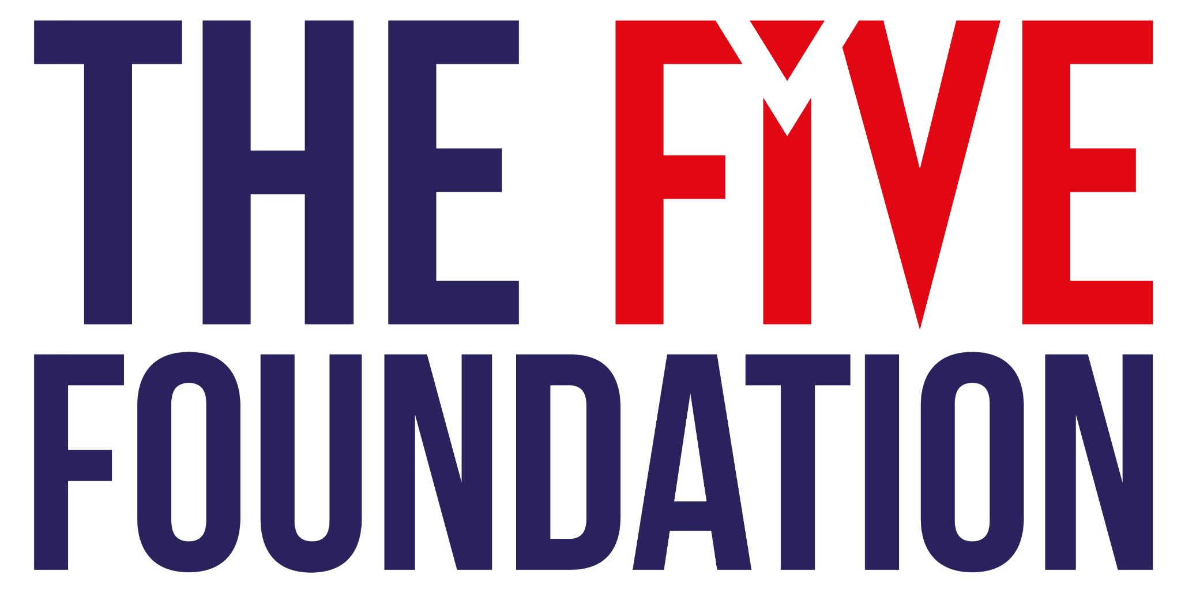

SIMPLE TRACKING TOOL TO MEASURE EFFECTIVENESS OF FGM INTERVENTIONS, OCT 2021

This tool is based on UNICEF’s ACT Framework for tracking changes in attitudes and behaviour to end FGM. The original/long version is here.

The aim of the tool is to track the success of grassroots initiatives to end FGM in terms of changing behaviours - and to evaluate how many girls age 0-14 years were protected during this time. Although this isn’t foolproof (girls can be cut over age 14), and is a very simplified version of UNICEF’s intensive tool, it is a starting point to measuring impact and gives a clear indication of change over time.

INTERVIEW WITH FATHERS OF GIRLS POTENTIALLY AT RISK OF FGM

Note: Print Pages 2 and 3. Fill in before and after (time frame to be determined by partner) the activities have taken place.

Aim to interview at least 10-20% of those individuals you hope to persuade to protect girls from FGM.

If you are not targeting men, then interview mothers/grandmothers, etc. instead.

BEFORE ACTIVITIES TAKE PLACE

NAME OF INTERVIEWER: ____________________________________

NAME OF INTERVIEWEE: ____________________________________

DATE OF INTERVIEW 1: ____________________________________

VILLAGE/COMMUNITY: ____________________________________

APPROX NUMBER OF GIRLS AT RISK IN COMMUNITY: ____________

 |  | a | b | c | d | e
1 | Do you have daughters at risk of FGM? | Yes | Maybe | Not sure | No
2 | Do you have daughters who have been cut? | Yes | Maybe | Not sure | No
3 | Do you plan for your daughter to have FGM? | Yes | Maybe | Not sure | No
4 | Are girls in your community already cut? | All | Most | Some | Few | None
5 | Do you think FGM should continue? | Yes | Maybe | Not sure | No
6 | Do people in your community or people whose opinion you value support FGM? | All | Most | Some | Few | None
7 | How many men in your community would marry women who have not undergone FGM? | All | Most | Some | Few | None
8 | Have you or wiill you encourage others to abandon FGM? | Yes | Maybe | Not sure | No
9 | In five years from now, do you think girls in this community will have undergoing FGM? | All | Most | Some | Few | None

AFTER ACTIVITIES TAKE PLACE

NAME OF INTERVIEWER: ____________________________________

NAME OF INTERVIEWEE: ____________________________________

DATE OF INTERVIEW 2: ____________________________________

VILLAGE/COMMUNITY: ____________________________________

APPROX NUMBER OF GIRLS AT RISK IN COMMUNITY: ____________

 |  | a | b | c | d | e
1 | Do you have daughters at risk of FGM? | Yes | Maybe | Not sure | No
2 | Do you have daughters who have been cut? | Yes | Maybe | Not sure | No
3 | Do you plan for your daughter to have FGM? | Yes | Maybe | Not sure | No
4 | Are girls in your community already cut? | All | Most | Some | Few | None
5 | Do you think FGM should continue? | Yes | Maybe | Not sure | No
6 | Do people in your community or people whose opinion you value support FGM? | All | Most | Some | Few | None
7 | How many men in your community would marry women who have not undergone FGM? | All | Most | Some | Few | None
8 | Have you or wiill you encourage others to abandon FGM? | Yes | Maybe | Not sure | No
9 | In five years from now, do you think girls in this community will have undergoing FGM? | All | Most | Some | Few | None

Gather information on an Excel sheet and input responses as 1a, 2a, etc.

Then compare responses from the first set of interviews compared to the second set to see if the father (or other decision makers in the family) are now more likely to protect their daughter or other girls at risk of FGM.

